**JAVASCRIPT PRACTICALS**

**A1. Write a JavaScript program to calculate area of triangle, area of rectangle and area of circle.**

<!DOCTYPE html>

<html lang="en">

<head>

<meta charset="UTF-8">

<meta name="viewport" content="width=device-width, initial-scale=1.0">

<title>Document</title>

</head>

<body>

<list>

<button onclick="area_triangle()" id="btnl1"> triangle</button>

<button onclick="area_circle()" id="btnl2"> area_circle</button>

<button onclick="area_rectangle()" id="btnl3"> rectangle</button>

</list>

<script>

function area_triangle() {

var side1 = parseInt(prompt("Enter side1 in cm "));

var side2 = parseInt(prompt("Enter side2 in cm "));

var side3 = parseInt(prompt("Enter side3 in cm "));

var sumofside= side1 + side2 + side3;

var s = sumofside / 2;

// var s = (side1 + side2 + side3) / 2;

//var area = Math.sqrt((s*(s - side1) * (s - side2) * (s - side3)));

var s1= s - side1;

var s2= s - side2;

var s3= s - side3;

var area= s* s1 * s2* s3;

console.log( "area of triangle is=" + area.toFixed(2) + "sq.cm ");

document.write("<br>area of triangle is =" + area.toFixed(2) + "sq.cm ");

}

function area_rectangle() {

var side1 = parseInt(prompt("Enter side1"));

var side2 = parseInt(prompt("Enter side2"));

var area = side1 * side2;

console.log("<br>" + "area of rectangle is " + area.toFixed(2) + "sq.cm");

document.write("<br>" + "area of rectangle is =" + area.toFixed(2) + "sq.cm");

}

function area_circle() {

var radius = parseInt(prompt("Entr the radius in cm"))

var ar = 3.14 * radius * radius;

console.log("<br>" + "Area of Circle is=" + ar.toFixed(2) + "")

document.write("<br>" + "Area of Circle is=" + ar.toFixed(2) + "")

}

</script>

</body>

</html>**Output:--**

FIRST VIEW

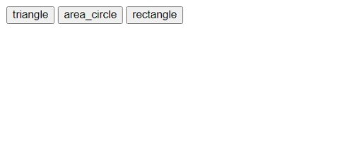

After clicking for input

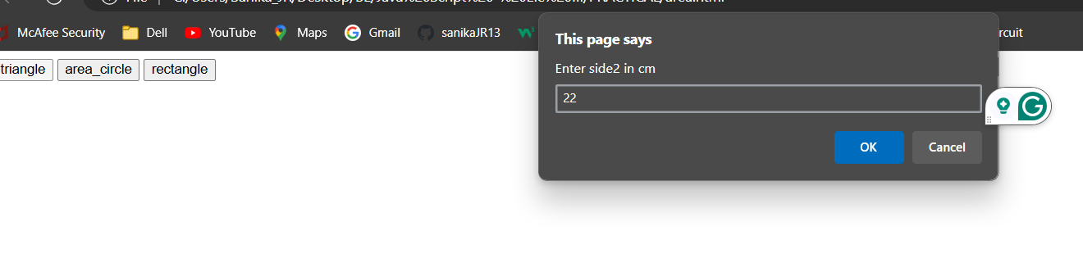

After finding area--

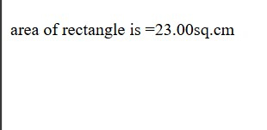

**A2. Write a JavaScript program to generate the multiplication table of a given number.**

<!DOCTYPE html>

<html>

<head>

    <title>Multiplication Table</title>

</head>

<body>

    <h3>Multiplication Table and Testing NaN</h3>

    <p>Please perform testing NaN first</p>

    <button onclick="tNaN()" id="btnl">Test NaN</button>

    <br><br>

    <input id="text" placeholder="Enter Number">

    <button onclick="mtable()" id="btnl">Generate Multiplication Table</button>

    <div id="table-output"></div>

    <script>

        function tNaN() {

            // Test NaN and Infinity

            const n1 = parseInt(prompt("Enter an integer to test"), 10);

            console.log("n1 is " + n1);

            const n2 = n1 / 0;

            console.log("n1/0 is " + n2);

            const n3 = -n1 / 0;

            console.log("-n1/0 is " + n3);

            // Test if a string divided by 2 results in NaN

            const s1 = prompt("Enter a character string to test");

            const n4 = s1 / 2;

            console.log("s1/2 is " + n4);

        }

        function mtable() {

            // Clear previous output

            const outputDiv = document.getElementById("table-output");

            outputDiv.innerHTML = '';

            // Get the number from input

            const num = parseInt(document.getElementById("text").value, 10);

            // Check if input is valid

            if (isNaN(num)) {

                outputDiv.innerHTML = "Please enter a valid number.";

                return;

            }

            // Generate and display multiplication table

            let tableHTML = "<h4>Multiplication Table for " + num + ":</h4>";

            for (let i = 1; i <= 10; i++) {

                const result = i * num;

                tableHTML += num + " * " + i + " = " + result + "<br>";

            }

            outputDiv.innerHTML = tableHTML;

        }

    </script>

</body>

</html>

**OutPut:-**

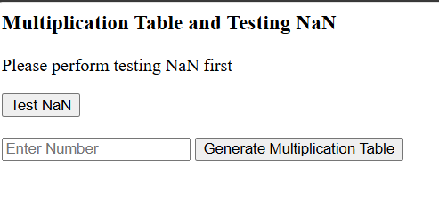

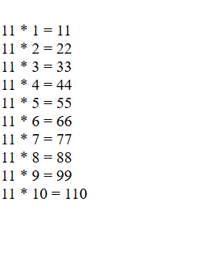

**A3. Write a JavaScript program to following operations on a given string, • Reverse string • Replace characters of a string. • String is Palindrome.**

1. **Prog to replace a character of a string**

<!DOCTYPE html>

<html>

<head>

<meta charset="UTF-8" />

<title>program to replace only a character of a string</title>

</head>

<body>

<script>

//Replace first occurance

const string = prompt('Enter a string: ');

// replace the characters

const newText = string.replace('r', 'b');

console.log(newText);

document.write(newText+"<br>");

//Replace charcter

const regex = /r/g;

const newText1 = string.replace(regex, 'b');

// display the result

console.log(newText1);

document.write(newText1);

</script>

</body>

</html>

**Output:-**

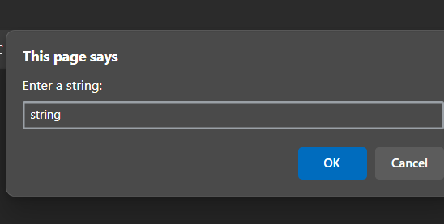

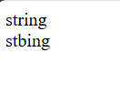

**2) Reverse a string using for loop**

<!DOCTYPE html>

<html>

<head>

<h1>Program to reverse a string using for loop</h1>

</head>

<body>

<script>

function reverseString(str) {

// empty string

let newString = "";

for (let i = str.length - 1; i >= 0; i--) {

newString += str[i];

}

return newString;

}

// take input from the user

const string = prompt('Enter a string: ');

const result = reverseString(string);

document.write(result);

</script>

</body>

</html>

**Output:-**

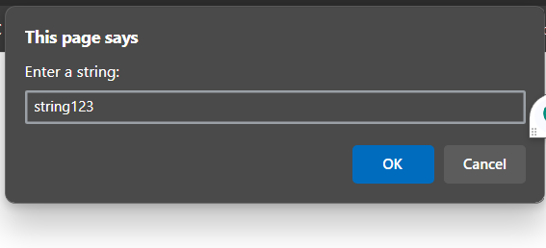

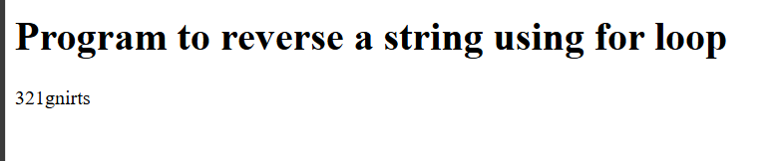

1. **Reverse a string using built-in method**

<!DOCTYPE html>

<html>

<head>

<meta charset="UTF-8" />

<title>program to reverse a string using built-in method</title>

</head>

<body>

<script>

function reverseString(str) {

// return a new array of strings

const arrayStrings = str.split("");

// reverse the new created array elements

const reverseArray = arrayStrings.reverse();

// join all elements of the array into a string

const joinArray = reverseArray.join("");

// return the reversed string

return joinArray;

}

// take input from the user

const string = prompt('Enter a string: ');

const result = reverseString(string);

console.log(result);

document.write(result);

</script>

</body>

</html>

**Output:-**

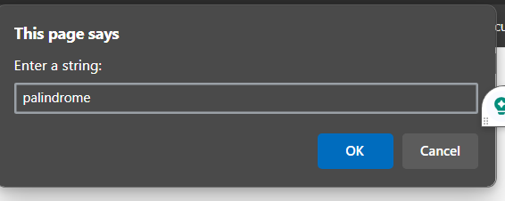

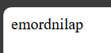

1. **Palindrome using built-in method**
2. <!DOCTYPE html>
3. <html>
4. <head>
5. <meta charset="UTF-8" />
6. <title>program to reverse a string using built-in method</title>
7. </head>
8. <body>
9. <script>
10. function reverseString(str) {
11. // return a new array of strings
12. const arrayStrings = str.split("");
13. // reverse the new created array elements
14. const reverseArray = arrayStrings.reverse();
15. // join all elements of the array into a string
16. const joinArray = reverseArray.join("");
17. // return the reversed string
18. return joinArray;
19. }
20. // take input from the user
21. const string = prompt('Enter a string: ');
22. const result = reverseString(string);
23. console.log(result);
24. document.write(result);
25. </script>
26. </body>
27. </html>

**Output:-**

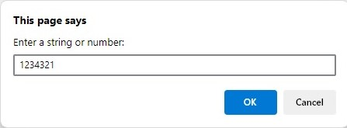

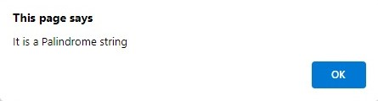

1. **Palindrome using CSS**

<!DOCTYPE html>

<html>

<head>

<title> Palindrome Program in JavaScript </title>

<style>

h1 {

text-align: center;

padding: 30px;

background-color: blue;

color: white;

}

.palin {

margin: 30px;

width: 80%;

border: 3px solid rgb(138, 9, 9);

border-radius: 5px;

padding: 30px;

}

#pa2 {

width: 50%;

border: 3px solid orangered;

border-radius: 5px;

padding: 10px;

}

</style>

</head>

<body>

<h1> Palindrome Program in JavaScript </h1>

<div class="palin">

<label> Enter any string or number : </label>

<input id= "pa"> <br> <br>

<label> Resultant string : </label>

<input id = "pa2" > </b> <br>

<input type= "submit" onclick = "palindrome()" > <br>

</div>

<script type = "text/javascript">

function palindrome()

{

var a= document.getElementById("pa").value;

// get the total length of the words

var b="";

// Use for loop to divide the words into 2 half

for (let i = a.length-1; i >=0; i--) {

b+=a[i];

}

// validate the first and last characters are same

if (a==b)

document.getElementById("pa2"). value = b + " is a Palindrome String ";

else

document.getElementById("pa2"). value = b + " is not a Palindrome String";

}

</script>

</body>

</html>

Output:-

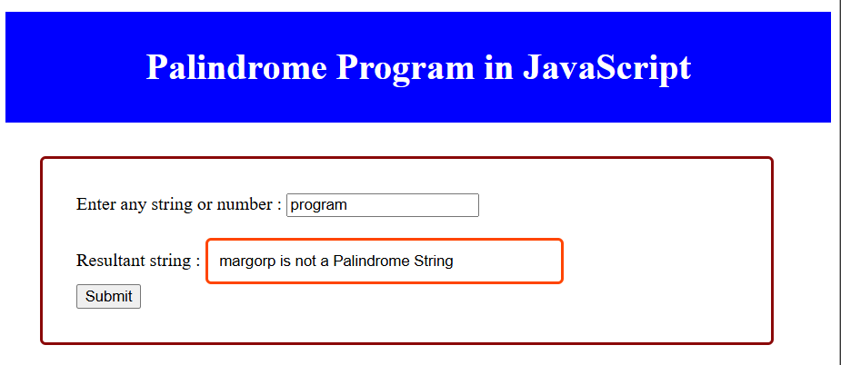

1. **Program to reverse, replace a character of a string and check whether entered string is Palindrome in JavaScript**

<!DOCTYPE html>

<html>

<head>

<title> program to reverse,replace a character of a string and check whether entered string is Palindrome in JavaScript </title>

<style>

    h1 {

    text-align: center;

    padding: 100px;

    background-color: blue;

    color: white;

    }

    .palin {

    margin: 30px;

    width: 80%;

    border: 3px solid rgb(138, 9, 9);

    border-radius: 5px;

    padding: 50px;

   }

    #pa2 {

    width: 50%;

    border: 3px solid orangered;

    border-radius: 5px;

    padding: 5px;

   }

    #ra {

    width: 50%;

    border: 3px solid orangered;

    border-radius: 5px;

    padding: 5px;

    }

    #rc {

    width: 50%;

    border: 3px solid orangered;

    border-radius: 5px;

    padding: 5px;

    }

    </style>

</head>

<body>

        <h1> Program to reverse,replace a character of a string and check whether entered string is Palindrome in JavaScript  </h1>

        <div class="palin">

        <label> Enter any string or number : </label>

        <input id= "pa"> <br> <br>

        <label> Reverse of a string : </label>

        <input id= "ra"> <br> <br>

        <label> Replace charcter r with b : </label>

        <input id= "rc"> <br> <br>

        <label> Resultant string : </label>

         <input id = "pa2" > </b> <br>

         <button onclick= "reverseString();replacestring();palindrome();" >Submit</button> <br>

        </div>

        <script type = "text/javascript">

        function reverseString()

        {

            var a= document.getElementById("pa").value;

            var newString = "";

                for (let i = a.length - 1; i >= 0; i--)

                    {

                    newString += a[i];

                    }

                document.getElementById("ra"). value = newString + " ";

        }

        function replacestring()

        {

            var a= document.getElementById("pa").value;

            const regex = /r/g;

            var newText1 = a.replace(regex, 'b');

            document.getElementById("rc"). value = newText1 + " ";

        }

        function palindrome()

        {

        var a= document.getElementById("pa").value;

          // get the total length of the words

        var b="";

            // Use for loop to divide the words into 2 half

            for (let i = a.length-1; i >=0; i--)

            {

                b+=a[i];

            }

        // validate the first and last characters are same

        if (a==b)

        document.getElementById("pa2"). value = b + " is a Palindrome String ";

        else

        document.getElementById("pa2"). value = b + " is not a Palindrome String";

        }

        </script>

        </body>

        </html>

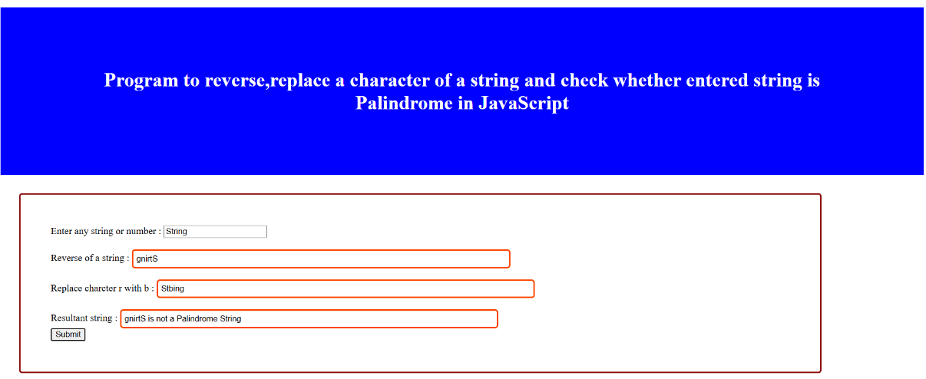

**A4. Write a JavaScript program to compare two strings using various methods.**

Using uppercase

<!DOCTYPE html>

<html>

<head>

<title>method1 is string compare using upper case</title>

</head>

<body>

<script>

const string1 ='JavaScript Program';

const string2 ='javascript pragram';

//compare both strings

const result =string1.toUpperCase()===string2.toUpperCase();

if(result)

{

console.log("The strings are equal");

document.write("The string are equal");

}

else

{

console.log("The strings are not equal");

document.write("The string are not equal");

}

</script>

</body>

</html>

**OUTPUT :**

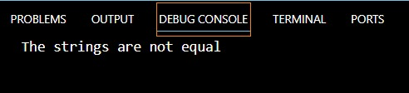



2) Using regex

<!DOCTYPE html>

<html>

<head>

<title>compare string using regex</title>

</head>

<body>

<script>

const string1 ='JavaScript Program';

const string2 ='javascript program';

//create regex

const pattern =new RegExp(string1,"gi");

//compare the strings

const result =pattern.test(string2);

if(result)

{

console.log("strings are equal");

document.write("strings are equal");

}

else

{

console.log("The strings are not equal");

document.write("strings are not equal");

}

</script>

</body>

</html>

**OUTPUT :**

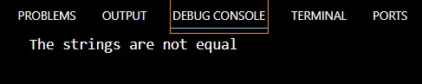



3) Using localeCompare

<!DOCTYPE html>

<html>

<head>

<title>method3 using localeCompare</title>

</head>

<body>

<script>

const string1 ='JavaScript Program';

const string2 ='javascript program';

//to compare

const result =string1.localeCompare(string2);

if(result==0)

{

console.log("strings are equal");

document.write("strings are equal");

}

else

{

console.log("The strings are not equal");

document.write("strings are not equal");

}

</script>

</body>

</html>

**OUTPUT :**

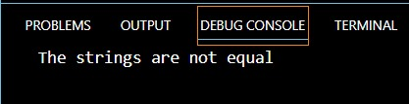



**A5. Write a JavaScript program that will create a countdown timer.**

<!DOCTYPE html>

<html>

<head>

<!-- Display the countdown timer in an element -->

<h3> Building Coundown Timer Using Date Function </h3>

</head>

<body>

<p id="demo"></p>

<script>

// Set the date we're counting down to

var tDate = new Date();

var month = tDate.getMonth() + 1; // Add 1 to get the correct month (1-12)

var day = tDate.getDate(); // Use getDate() to get the day of the month (1-31)

document.write("<BR>" + "Todays Date is " + tDate);

document.write("<BR>" + "Month is " + month);

document.write("<BR>" + "Day is " + day);

document.write("<BR>" + "Time is " + tDate.getTime() + "msec");

var t = tDate.getTime();

var countDownDate = new Date("Aug 17, 2024 10:58:25").getTime();

var diff = countDownDate - t;

document.write("<BR>" + "Time in msec from 1 Jan 1970 till Jan 5, 2024 is "+ countDownDate);

//JavaScript stores dates as number of milliseconds since January 01, 1970. Zero time is January 01, 1970 00:00:00 UTC.

document.write("<BR>" + "Difference " + diff);

// Update the count down every 1 second

var x = setInterval(function(){

// Get today's date and time

var now = new Date().getTime();

// Find the distance between now and the count down date

var dit = countDownDate - now;

// Time calculations for days, hours, minutes and seconds

var days = Math.floor(dit / (1000 * 60 * 60 * 24));

var hours = Math.floor((dit % (1000 * 60 * 60 * 24)) / (1000 * 60 * 60));

var minutes = Math.floor((dit % (1000 * 60 * 60)) / (1000 * 60));

var seconds = Math.floor((dit % (1000 * 60)) / 1000);

// Display the result in the element with id="demo"

document.getElementById("demo").innerHTML = days + "d " + hours + "h "

+ minutes + "m " + seconds + "s ";

// If the count down is finished, write some text

if (dit < 0) {

clearInterval(x);

document.getElementById("demo").innerHTML = "EXPIRED";

}

}, 1000);

</script>

</body>

</html>

**Output :**

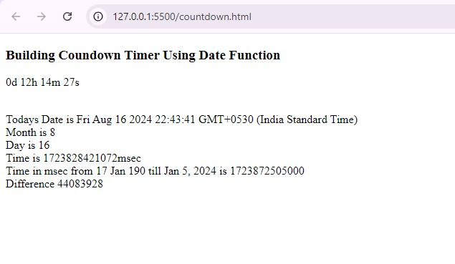

**B1. Manipulation of an array**

**Write a JavaScript program that will create an array and perform following operations,**

* **To remove specific element from the array.**
* **Check if the array contains a specified value.**
* **To empty an array**

# <!DOCTYPE html>

# <html lang="en">

# <head>

# <title>Array Operations</title>

# </head>

# <body>

# <h1>Javascript Practical of Array manipulation</h1>

# <script>

# var array = [];

# var x = prompt("Enter the size of array");

# //Input the elements in the array

# for (i=0;i<x;i++)

# {

# array[i] = prompt('Enter array Element ' + (i+1)); }

# //Display the array elements

# document.write("Array entered is" +"</br> </br>");

# for (i=0;i<x;i++)

# {

# 

# document.write("The element at position " + (i) + " is : " + array[i] + "</br> </br>");

# }

# //A. Remove element from array

# function removeElement(removeEle)

# { var removeEle = prompt('Enter array Element to delete ' );

# for (i=0;i<x;i++)

# { if(array[i]== removeEle)

# {

# // array.remove(i);

# document.write("After deleting array element:  "+ array[i] + "   array is"+"</br> </br>");

# delete array[i];

# }

# }

# }

# //B. Check for a specific value

# function searchElement(searchEle)

# {

# var searchEle = prompt('Enter array Element to find ' );

# let pres=false;

# pres=  array.includes(searchEle);

# if(pres == true)

# {

# document.write("Element " + searchEle + " is present in the array</br></br>");

# }

# else

# document.write("Element " + searchEle + "  is not present in the array</br></br>");

# }

# //searchElement(searchEle);

# //C. To empty an array

# function emptyArray()

# {

# array.splice(0,array.length);

# if(array.length == 0)

# {

# document.write("Array is empty now using splice method")

# }

# document.write(array); }

# removeElement();

# //Display the array elements

# for (i=0;i<x;i++)

# { document.write("The element at position " + (i) + " is : " + array[i] + "</br> </br>"); }

# searchElement();

# emptyArray() ;

# </script>

# </body>

# </html>

# OutPut:

# 

# 

# 

**B2. Appending Object to array and check if an object is an array**

**Write a JavaScript program that will append an object to an array and will check if an object is an array.**

<!DOCTYPE html>

<html lang="en">

<head>

<title>Append an Object to An Array</title>

</head>

<body>

<h1>JavaScript Program to Append an Object to An Array</h1>

<script>

var array = [];

var x = prompt("Enter the size of array");

//Input the elements in the array

for (i=0;i<x;i++)

{

array[i] = prompt('Enter array Element ' + (i+1));

}

//Display the array elements

for (i=0;i<x;i++)

{

document.write("The element at position " + (i) + " is : " + array[i] + "</br> </br>");

}

// program to append an object to an array using push() method

 function pushFunc(arr, obj)

{

// append object

arr.push(obj);

console.log(arr);

document.write("Using push method: "+arr + "</br></br>");

}

let obj1 = ["java","script"];

pushFunc(array, obj1);

// program to check if an object is an array

function checkObject(arr) {

// check if arr is array

const result = Array.isArray(arr);

if(result) {

console.log('[arr] is an array.');

 document.write("This is an array</br></br>");

}

else {

console.log('[arr] is not an array.');

document.write("This is not an array</br></br>");

}

}

checkObject(array);

console.log(array);

// program to append an object to an array using splice() method

function spliceFunc(arr, obj) {

   // find the last index

    let index = arr.length;

    // appending object to end of array

    arr.splice(1, 5, obj2);

    console.log(arr);

document.write("Splicing at index 2: "+arr + "</br></br>");

}

// object to add

let obj2 = ["We","like"];

// call the function

spliceFunc(array, obj2 );

// program to append an object to an array using unshift() method

function unshiftFunc(arr, obj) {

// append object

arr.unshift(obj);

console.log(arr);

document.write("Using unshift method: "+arr + "</br></br>");

}

let obj3 = ["We","learn","and"];

unshiftFunc(array, obj3);

// program to append an object to an array using Spread operator

function spreadOperator(arr, obj) {

   // append object

    arr = [...arr, obj4];

    console.log(arr);

document.write("Using spread operator: "+arr + "</br></br>");

}

// object to add

let obj4 =  ["Program","Ended"];

// call the function

spreadOperator(array, obj4);

</script>

</body>

</html>

**Output:**

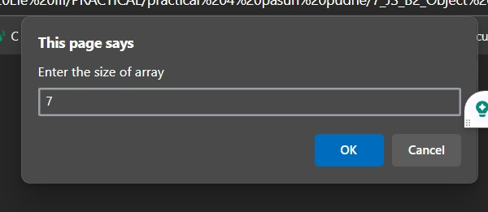

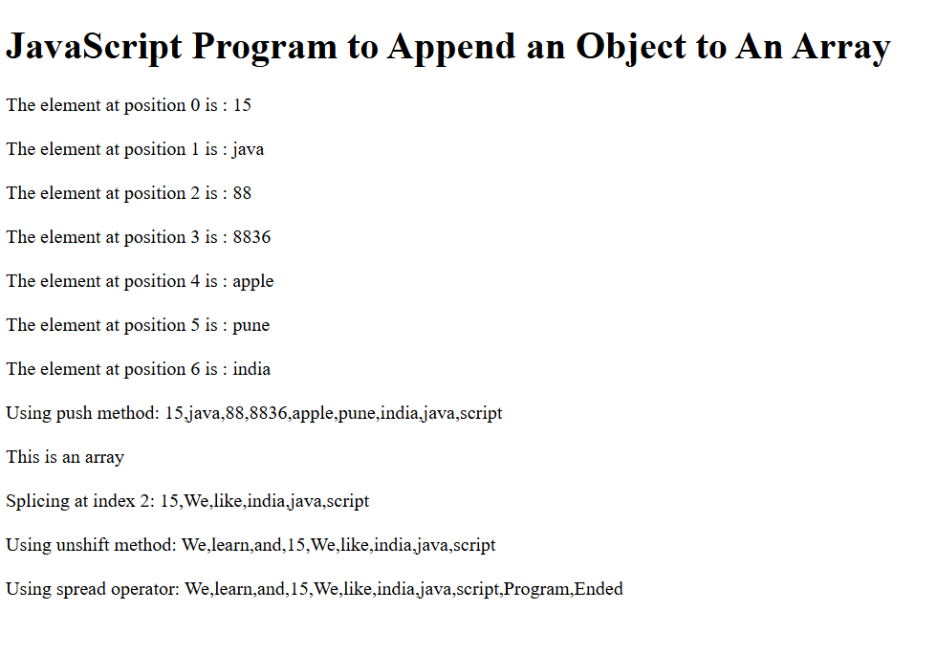

**B3. : Different Set Operations**

**Write a JavaScript program to illustrate different Set operations like:**

**\* Union**

**\* Intersection**

**\* Difference**

**\* Symmetric Difference**

<html>

<head>

<h2> Demonstrate Set Operations </h2>

<p> set A = ['apple', 'mango', 'orange'] </p>

<p> set B = ['grapes', 'apple', 'banana'] </p>

<p> set C = ['apple', 'orange'] </p>

<script>

// two sets of fruits

const setA = new Set(['apple', 'mango', 'orange']);

const setB = new Set(['grapes', 'apple', 'banana']);

const setC = new Set(['apple', 'orange']);

function union(a, b) {

    const unionSet = new Set(a);

    for (const i of b) {

        unionSet.add(i);

    }

return unionSet

}

const result1 = union(setA, setB);

console.log(result1);

document.write(result1);

function intersection(setA, setB) {

    const intersectionSet = new Set();

    for (let i of setB) {

        if (setA.has(i)) {

            intersectionSet.add(i);

        }

    }

return intersectionSet;

}

const result2 = intersection(setA, setB);

   console.log(result2);

   document.write(result2);

function difference(setA, setB) {

    let differenceSet = new Set(setA)

    for (let i of setB) {

        differenceSet.delete(i)

    }

 return differenceSet

}

const result3 = difference(setA, setB);

console.log(result3);

document.write(result3);

function subset(setA, setC) {

    for (let i of setC) {

        if (!setA.has(i)) {

            return false

        }

    }

    return true

}

const result = subset(setA, setC);

 console.log(result);

 document.write(result);

</script>

</head>

</html>

**Output:**

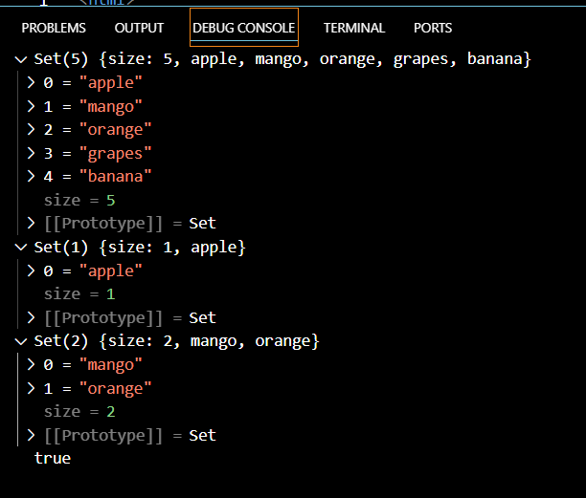

**C1. Write a JavaScript program to create a Home page of any website and change background color using**

* **On mouse over event**
* **On focus event**

<!DOCTYPE html>

<html>

<body>

<h2 align="center">A Home page of website that change background color using  •On mouse over event •On focus event</h2>

 <a onmouseover="document.body.style.backgroundColor ='#ADD8E6'"  style="margin:20px auto;

text-align:center;

display:block;

width:220px;"

class="button large hpbottom" >Hover over me to change the background color.</a><br>

  <a onmouseout="document.body.style.backgroundColor ='cyan'"style="margin:20px auto; text-align:center; display:block; width:220px;" class="button large hpbottom" >Hover out to change the background color.</a><br>

<h2 align="center">The focus Event</h2>

</body>

Enter your name: <input type="text" align="center" onfocus="myFunction(this)" onblur="blurFunction(this)" >

<script>

function myFunction(x) {

  x.style.background = "yellow";

}

function blurFunction(x) {

x.style.background  = "red";

}

</script>

</body>

</html>

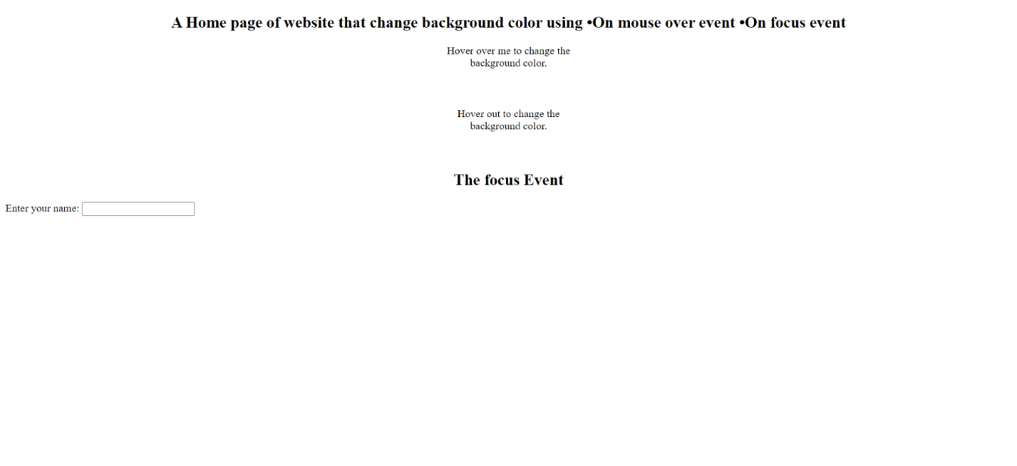

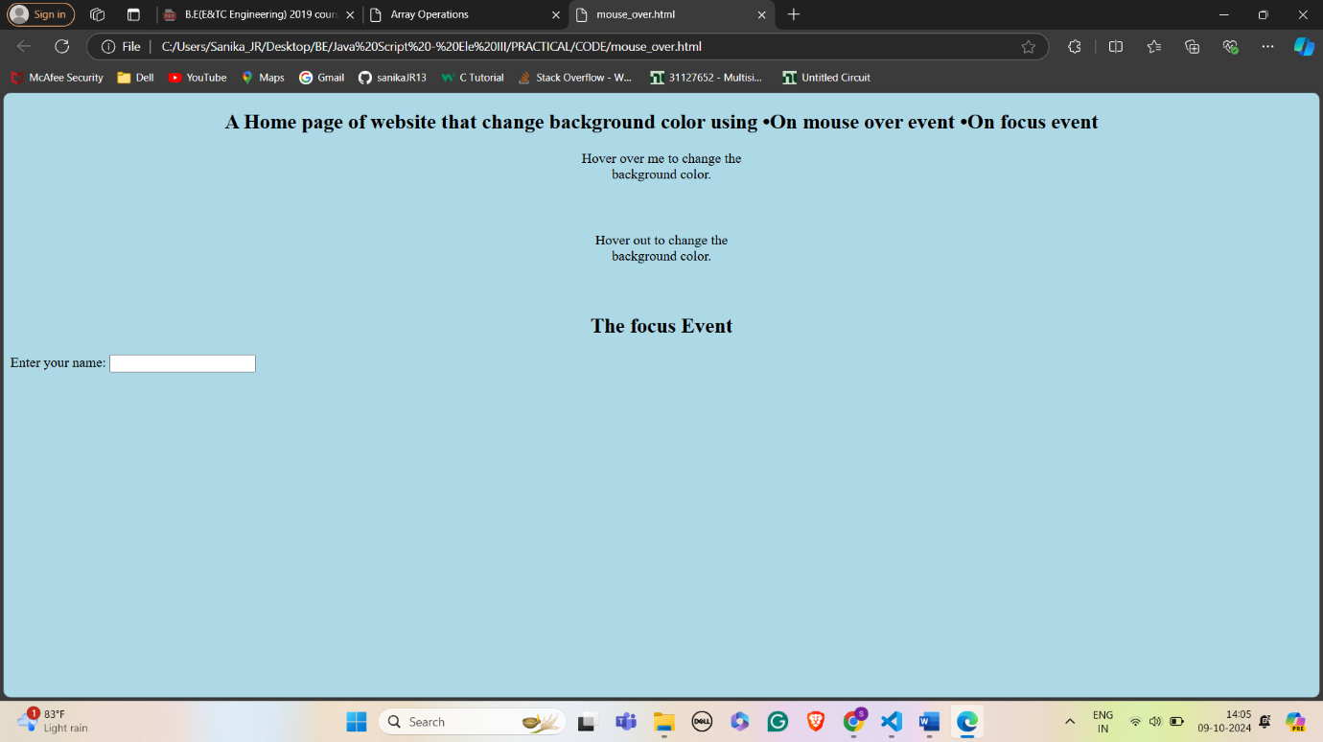

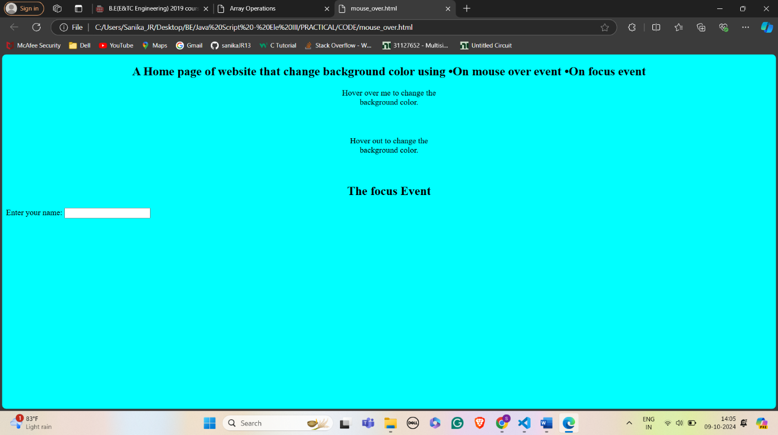

# 

# 

**C2. Create a student information Form to accept information like Name, Address, City, State Gender, Mobile Number, and email id. Perform validations for:**

* **Correct Names**
* **Mobile Names**
* **Email I.D.’s**
* **If no entered value**
* **Re-display for wrongly entered values with message**
* **Congratulation and Welcome page upon successful entries**

<!DOCTYPE html>

<html>

<head>

    <title>Student Information Form</title>

    <script>

        function validateForm() {

            var name = document.forms["myForm"]["name"].value;

            var address = document.forms["myForm"]["address"].value;

            var city = document.forms["myForm"]["city"].value;

            var state = document.forms["myForm"]["state"].value;

            var gender = document.forms["myForm"]["gender"].value;

            var mobile = document.forms["myForm"]["mobile"].value;

            var email = document.forms["myForm"]["email"].value;

            if (name == "" || address == "" || city == "" || state == "" || gender == "" || mobile == "" || email == "") {

                alert("Please fill out all fields.");

                return false;

            }

            var nameRegex = /^[A-Za-z\s]+$/;

            if (!name.match(nameRegex)) {

                alert("Invalid Name.");

                return false;

            }

            var mobileRegex = /^\d{10}$/;

            if (!mobile.match(mobileRegex)) {

                alert("Invalid Mobile Number.");

                return false;

            }

            var emailRegex = /^[a-zA-Z0-9._-]+@[a-zA-Z0-9.-]+\.[a-zA-Z]{2,4}$/;

            if (!email.match(emailRegex)) {

                alert("Invalid Email ID.");

                return false;

            }

            alert("Congratulation and Welcome!");

            return true;

        }

    </script>

</head>

<body>

    <form name="myForm" action="/submit_form" onsubmit="return validateForm()" method="post">

        <label for="name">Name:</label><br>

        <input type="text" id="name" name="name"><br>

        <label for="address">Address:</label><br>

        <input type="text" id="address" name="address"><br>

        <label for="city">City:</label><br>

        <input type="text" id="city" name="city"><br>

        <label for="state">State:</label><br>

        <input type="text" id="state" name="state"><br>

        <label for="gender">Gender:</label><br>

        <input type="text" id="gender" name="gender"><br>

        <label for="mobile">Mobile Number:</label><br>

        <input type="text" id="mobile" name="mobile"><br>

        <label for="email">Email ID:</label><br>

        <input type="text" id="email" name="email"><br>

        <input type="submit" value="Submit">

    </form>

</body>

</html>

**Output:**

